CHAPTER 2: Getting into genes

Worksheet 2.4

Meiosis
Answers

Meiosis in plants and the human female
1. Identify the labelled parts in each illustration below showing where meiosis occurs.
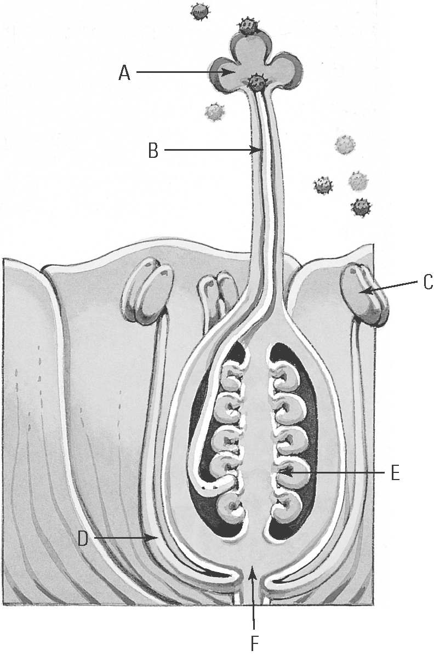 | 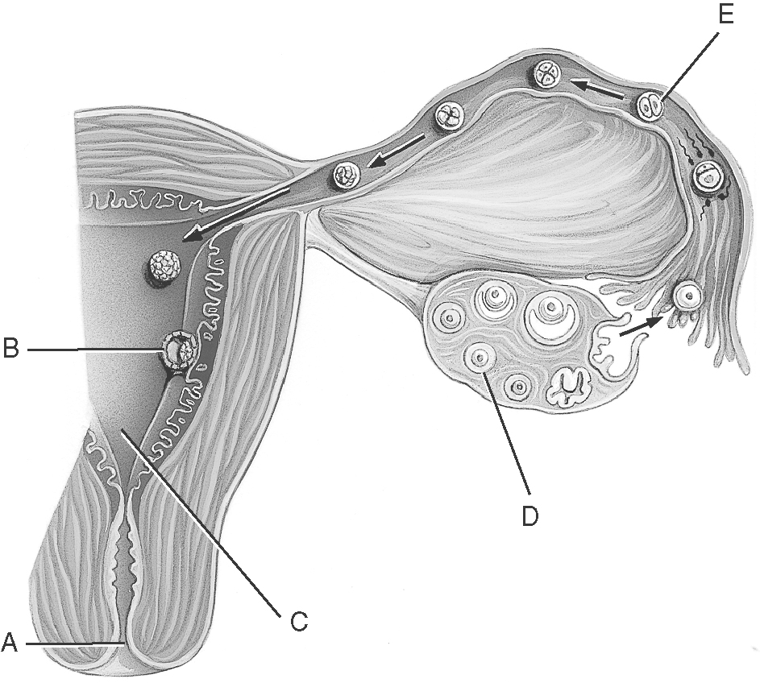  D
(a) Plant: .................................................. (b) Human female: .........................................
C and E

True or false
2. Answer ‘true’ or ‘false’ to each of the following statements about meiosis.
True
(a) Meiosis is a process that results in the production of gametes. ..................................
True
(b) Meiosis occurs in two stages producing two cell divisions. .......................................
(c) New cells produced by meiosis have the same chromosomal number as the
original cell. ...........................
False

Second meiosis division
3. Complete the diagram of the second meiosis division to show the chromatids in the gametes.
